Article from SSENSE

General Article Format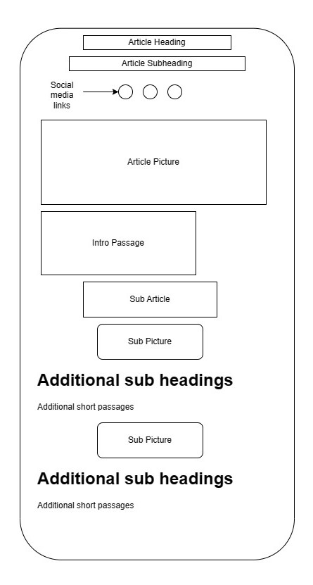

[This Is England: Why Britain Is the Belle of the Ball for FW23 | SSENSE](https://www.ssense.com/en-us/editorial/fashion/english-designers-fashion-trend)

By Alek Rose

26 July, 2023

**THIS IS ENGLAND: WHY BRITAIN IS THE BELLE OF THE BALL FOR FW23**

**Unpacking the historical and cultural forces behind fashion’s burgeoning obsession with the UK.**

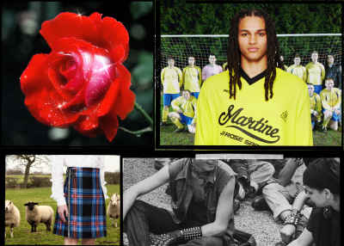

Intro ::

In the year of King Charles’s coronation, Britain also commemorates the seventy-fifth anniversary of Windrush, the generation of Caribbean people who arrived in the UK between 1948 and 1973 and suffered at the hands of Britain’s unethical immigration system; it’s safe to say that this is a country with a complicated cultural identity. From classical performances to garage raves, British culture runs the gamut from historic traditions to fresh new perspectives. This spread is peppered with pithy cultural archetypes that are, at least on the surface, recognizable to an international audience, but on a deeper level, wholly unfamiliar. The ability to reference and explore these famous subcultural phenomena is, perhaps, what makes English sartorial history such a central focus on FW23 runways.

First Passage

Although this trend asserted itself in FW23, the writing has been on the wall for several seasons. From the unbridled success of Wales Bonner’s exploration of silhouettes like the adidas Samba and retro tracksuits to TikTok’s blokecore revolution, in which American 20-somethings took passionately to a style popularized by fashion-hating football fans, British style has proven to be an attractive force even for international audiences.

If FW23 presentations were anything to go by, this trend is showing no signs of slowing. So, before you don a kilt and a Stone Island jacket for a trip to the pub, make sure you know your punks from your blokes.

First Photo



Additional passages and photos

BLOKES

To the dismay of many Brits, one of the most prolific TikTok style trends of the last few years has been blokecore: the art of dressing like a bloke. Think vintage football tops, jeans, and adidas footwear. While 2020 may have been your local TikTok star’s first taste of this cocktail, it’s a subculture deeply entrenched in British life. Sure, Elijah Wood was reluctantly welcomed into the world by the scene’s chosen one, Danny Dyer, in 2005’s seminal film Green Street, but the roots of this culture stretch back decades before that.

Since the late ‘80s, England has been the home of Casuals, British lads who started traveling the world (Western Europe) to watch football, picking up—lawfully or otherwise—gear in these new cities. The clothing they brought shaped the exclusive aesthetic of the subculture, with European labels like C.P. Company, Stone Island, Lacoste, and more becoming commonplace signifiers of a lifestyle beyond just watching football.

While classic names like Fred Perry, adidas, and the aforementioned European brands continue to do what they’ve always done—only now for a younger customer less interested in football violence than Instagram reshares—some designers are putting a more luxurious spin on the style. The new British design language for luxury is typified in Grace Wales Bonner’s retro palettes and the details inspired by her British-Jamaican heritage. You see the new language as well in Martine Rose’s bold proportions, gathered seams, and generally subversive perspective.

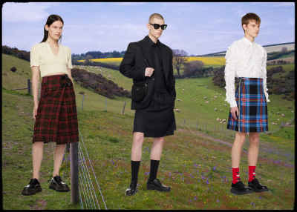

KILTS

Kilts are not English. This is an essential disclaimer before SSENSE suffers a Scottish boycott. But, while they may not be as deeply embedded in English life as a Fred Perry track jacket, kilts are an unmissable aspect of British visual identity.

Traditionally cut from wool woven with a unique family tartan and famously worn without underwear, kilts are a vestige of British sartorial history unlike any other. The pleated, wraparound build has understandably attracted designers thanks to its daringness and long history, which dates back to the sixteenth century as a heavy, utilitarian evolution of the tunic.

In terms of luxury fashion, the mind immediately turns to the grand dame of punk, Vivienne Westwood, whose rebellious designs cleared the way for an entire subculture to flourish stylistically from the early ‘70s. Westwood also inspired younger creators like Charles Jeffrey, who founded his label LOVERBOY in 2015 and achieved almost immediate acclaim. He’s still flying the flag high for the garment. “When it comes to designing collections, the kilt features heavily because of my Scottish heritage, I also think it’s a garment that smashes gender norms. It‘s got this incredible history and vibe that I just can‘t resist,” Jeffrey notes. “I love how Jean Paul Gaultier worked with the kilt, making it fluid and luxurious, made in printed silks. Those pleats are really provocative on a man‘s body, while the tartans tell stories of heritage and individuality which I love to play with alongside the narrative of the collection I design.”



ENGLISH ROSE

From the athletic silhouettes of blokecore to audacious tartan kilts and loud punk styling, British culture’s variety is what makes it such rich source material for designers. It also means it’s easy to slot into as a customer. For those looking to play with the more elegant side of British identity—we’re talking Keira Knightley in Pride & Prejudice—then the English rose trope is key.

The red rose is England’s national flower, symbolizing much, ranging from the fifteenth-century Wars of the Roses to the simple, unspoiled natural beauty of the isle’s landscapes. During FW23 presentations, different configurations of the rose continued to surface, tapping into this symbolic power.

Daniel Lee‘s first Burberry collection, Vivienne Westwood, and Chopova Lowena, were major pillars of this trend, but it’s worth noting that non-British brands like Maison Margiela and Dries Van Noten explored it as well, with ethereal drapes, silks, and classic tailoring elements.

Whether it’s a floral motif or a more direct translation of the English rose character trope, the fragile, elegant beauty of this trend stands in contrast to most other sides of British identity. Far from the chants of football stadia, far from the piercings and distressed seams of punk, the English rose stands out as a welcome nod to the more gentle aspects of the British condition.

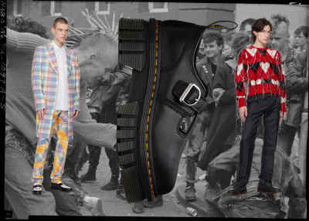

PUNK

Punk needs no introduction. It’s been one of Britain’s defining subcultures over the last century. Emerging in the 1970s as a rebellion against conservative British politics, the culture is most famous for its music and style. Artists like the Sex Pistols and The Clash soundtracked the era of wild haircuts, drainpipe jeans, beaten leather jackets, and heavy leather boots.

Punk’s expression in fashion walks hand in hand with the kilt trend, as kilts have long been part of the punk uniform. It tracks, then, that Vivienne Westwood is a protagonist in punk style language, having shaped the look alongside Malcolm McLaren at Let It Rock, an iconic punk store in West London.

Punk is arguably the most popular and therefore the most easily obtainable trend in this group. Names like Comme des Garçons Homme Plus, Chopova Lowena, and Charles Jeffrey LOVERBOY offer modern reinterpretations of the subculture, standing by the rebellious irreverence that has always characterized the style.

What’s perhaps most fascinating about fashion’s carving up of British style is the reluctance of any of these legitimate subcultures to be marketed. The cultural importance of wearing a kilt for those who have grown up doing so makes it a bold statement in a nonceremonial situation. As for blokes, they’re about as far from the world of TikTok trends as any modern human could be, and that’s an active decision. Punk has long been a subculture based on deep-rooted, anti-capitalist philosophy that stretches much further than tartan trousers and a leather jacket; it’s a lifestyle.

It’s this kind of pride in the exclusivity of subculture, though, that makes British style so interesting. While fashion digs into Britain’s current visible style makeup, there’s a basement, studio, or club somewhere in the UK right now that’s building something new, and we know nothing about it. Yet.

[The It Novels for Summer (And Their It Girl Counterparts) | SSENSE](https://www.ssense.com/en-us/editorial/culture/the-it-novels-for-summer-and-their-it-girl-counterparts)

By Karah Preiss

July 24, 2023

# **The It Novels for Summer (And Their It Girl Counterparts)**

## BOOKS FOR YOUR BEACH BAG, AS SELECTED BY KARAH PREISS OF BELLETRIST.

As someone who coruns a “celebrity book club,” I am often asked the same question with equal parts desperation and excitement: What should I read next? This question is no more prevalent than in the summer, when it seems like everyone is looking for the definitive It Book or hot summer read. This summer, the question got me thinking about what “It” is and what makes something or someone inherently It.

The invention of the term It Girl is widely credited to the British novelist Elinor Glyn, who used “it” as a euphemism for sex in her novella of the same name, which was serialized in Cosmopolitan in 1927 and later became a silent film starring Clara Bow. In the beginning of the silent film, Glyn is featured and explains, in a title card, that: “Self-confidence and indifference as to whether you are pleasing or not—and something in you that gives the impression that you are not all cold. That’s ‘IT’!”

The term It Girl is now ubiquitous but still defies definition in its je ne sais quoi-ness. Part of what makes someone It is their undeniable yet undefinable It-ness. Nobody would question Edie Sedgwick’s It factor and yet it is hard to put a finger on just exactly what It is. For Glyn, It was a term she cooked up as a way of signaling someone’s sex appeal at a time when you couldn’t just write “sex appeal” in a novel or short story. We all know that being It is more than just being sexually appealing. The people who have It seem to both command and characterize the zeitgeist.

The idea to pair It Girls with It Books comes from a desire to get closer to a definition of It. The term itself has literary origins, which leads me to believe that if a person can be so effulgent that they become an icon of taste and character, can’t a book?

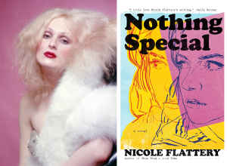

**Candy Darling, muse, actress, superstar / Nothing Special by Nicole Flattery (Bloomsbury)**

Candy came from out on the island / in the bathroom she was everybody’s darling—“Walk on the Wild Side” by Lou Reed

Candy Darling was a quintessential figure in Warhol’s Factory and Warhol’s films of the late 1960s. In many ways, the ’60s and ’70s encapsulate the second wave of It—a time when counterculture was the culture and a select few women, like Darling, were redefining ideas of womanhood. Nicole Flattery’s book attempts and succeeds in reflecting upon womanhood at that time as well.

Despite Warhol and his factory being well-trodden territory, Flattery’s sardonic coming-of-age novel, which follows two schoolgirls tasked with typing up Warhol’s recorded tapes, is fresh in that it is about a fictional character reflecting on her youth and only happens to take place in and around The Factory. Flattery’s novel is a perfect pairing with Darling in that they capture the intriguing lifeblood of the 1960s and early 1970s.



**Ayo Edebiri, actress / Francisco by Alison Mills Newman (New Directions)**

Ayo Edebiri is everything everywhere all at once. She rose to prominence in her role as Sydney Adamu on FX’s The Bear and will star in the feature film Bottoms later this summer. If It can be defined as an indifference to whether you are pleasing or not, then Edebiri is It. She feels thoroughly modern as an actress because she is both youthful and complex; emotional but not overly serious, which can probably be attributed to her standup comedy roots. It feels natural to pair Edebiri with Francisco, which is an old book with a new life. Alison Mills Newman’s novel, originally published in 1974, is the story of a young woman who falls in love with a filmmaker in San Francisco. Newman’s novel does not shy away from sexual frankness, but it is much more than that. It is about intimacy and about a woman trying to find her vocation in a difficult-to-navigate world. Both Edebiri and Francisco possess a timelessness that feels like a requirement for It status.

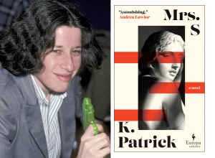

**Fran Lebowitz, writer / Mrs. S by K Patrick (Europa Editions)**

Our recent Franaissance could be a result of two documentaries in the past ten years, a robust public speaking calendar, and renewed interest in Lebowitz’s earlier work, but what is more likely is that Lebowitz possesses a primordial cool that firmly cements her It status. Mrs. S by K Patrick follows The Matron, a butch lesbian who has been tasked with overseeing an English boarding school. Things become interesting when the matron falls for the headmaster’s wife, Mrs. S. This novel pairs well with Lebowitz’s overt masculinity and her less-discussed lesbianism, but also is wry enough to live up to the insanely high comedic bar Lebowitz has set since she first published Metropolitan Life in 1978.

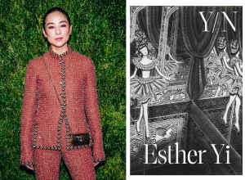

**Greta Lee, actress / Y/N by Esther Yi (Astra House)**

Greta Lee has made a name for herself with many offbeat roles over the past ten years, but the recent success of Past Lives, Celine Song’s film about a Korean-Canadian playwright whose life is upended when she reconnects with her childhood sweetheart, has skyrocketed Lee to a new tier of acting stardom. Esther Yi’s novel Y/N is about a Korean woman who begins writing fan fiction about a K-pop star named Moon. When Moon suddenly retires, the narrator of the novel picks up and goes to Korea in search of Moon and love. If there’s a role we’d love to see Lee sink her teeth into, it would be this one.

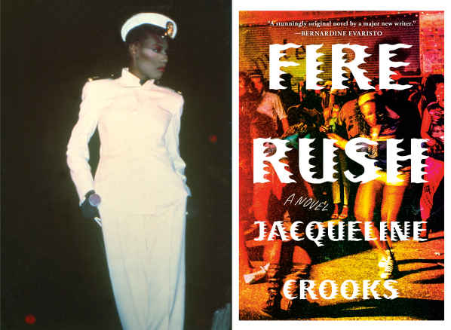

**Grace Jones, model, singer, and actress / Fire Rush by Jacqueline Crooks (Viking)**

There are cool people and then there’s Grace Jones. Jones was a pioneer of androgynous dress and built a persona that reached far beyond her early life in Jamaica and her move in her teens to Syracuse, New York. Jones has been cited as an inspiration by a number of today’s best-known contemporary artists, including Solange and Lorde, and in a time of such cultural attenuation continues to offer originality to contemporary music and culture.

Fire Rush is the story of Yamaye, a young Jamaican woman living in Bristol in the 1980s who falls in love with dancehall reggae in the Bristol underground. The novel is soulful and spiritual, but it is, most importantly, about the way in which music can unlock identity and excitement that we didn’t know we had.

Karah Preiss is a creative producer living in New York City. She cofounded [Belletrist book club](https://www.belletrist.com/) with actress Emma Roberts, along with Belletrist Productions, a TV and film production company.

<https://www.ssense.com/en-us/editorial/market/graphic-jeans-denim-trompe-loeil>

By August 2, 2023

# **TROMPE L’ŒIL DENIM IS FASHION’S SURREAL SUBVERSION OF A CLASSIC**

## False waistbands, digital distressing, and leather builds are just some of the ways Our Legacy, Y/Project, Bottega Veneta, and others are changing the face of contemporary denim.

## 

For maison [Valentino](https://www.ssense.com/en/women/designers/valentino)’s FW23 show entitled Un Château, Pier Paolo Piccioli walked a pair of relaxed-fit, straight-leg jeans down the runway. Groundbreaking. Only, this wasn’t an ordinary pair of jeans; it was made of thousands of tiny beads sewn together, giving the garment an ethereal sheen in motion. It’s not the first time we’ve seen a luxury house subvert staple denim. We only need to look back to [Bottega Veneta](https://www.ssense.com/en/women/designers/bottega-veneta)’s SS23 show, when Kate Moss walked down the runway in a pair of mind-bogglingly realistic stonewashed jeans made entirely of leather.

In 2023, this kind of optical illusion, or trompe l’oeil, has been deployed by many labels as a way of bringing surreal tension to timeless pieces like denim. Names like [Y/Project](https://www.ssense.com/en/women/designers/y-project), [Our Legacy](https://www.ssense.com/en/women/designers/our-legacy), and [Jean Paul Gaultier](https://www.ssense.com/en/women/designers/jean-paul-gaultier) have been leaders in the category, but labels are lining up to take the mantle as we look to bring new life to denim rotations.

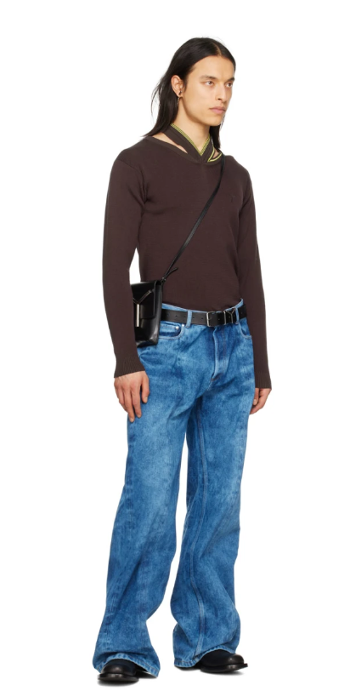

Model wears [Y/Project jeans](https://www.ssense.com/en/men/product/y-project/ssense-exclusive-blue-jeans/12457591).

[Y/Project SSENSE Exclusive Blue Jeans](https://www.ssense.com/en/men/product/y-project/ssense-exclusive-blue-jeans/12457591)

[Glenn Martens](https://www.ssense.com/en/editorial/fashion/yproject-is-the-millennial-atelier-we-deserve) has been a major player in the new wave of denim. The designer’s work at Diesel and Y/Project has frequently overlaid prints to find new ways of looking at classic pieces. Here, an acid wash and undulating seam to each leg result in an eye-catching silhouette.

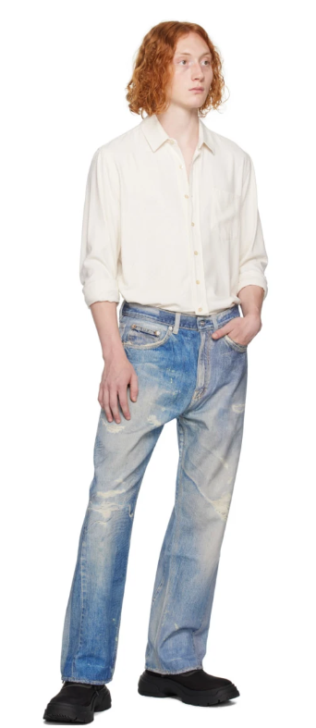

Model wears [Our Legacy jeans](https://www.ssense.com/en/men/product/our-legacy/blue-third-cut-jeans/13869501).

[Our Legacy Blue Third Cut Jeans](https://www.ssense.com/en/men/product/our-legacy/blue-third-cut-jeans/13869501)

It’s one thing buying a brand-new pair of jeans with preripped holes and distressed sections in them, but it’s a whole other game when those rips are merely printed onto immaculate denim. Our Legacy’s printed denim has been a major hit this season, offering unique textures and color palettes thanks to the digital finish.

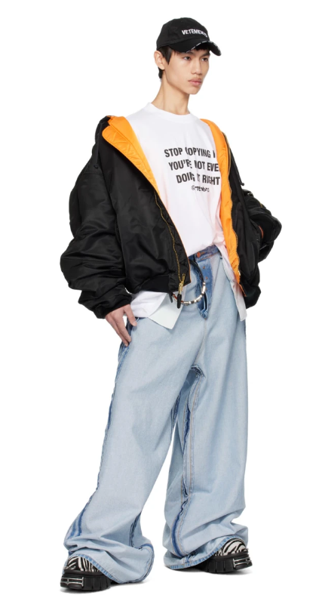

Model wears [VETEMENTS jeans](https://www.ssense.com/en/men/product/vetements/blue-inside-out-jeans/13500631).

[VETEMENTS Blue Inside Out Jeans](https://www.ssense.com/en/men/product/vetements/blue-inside-out-jeans/13500631)

VETEMENTS steers clear of surreal printing techniques and sticks to old-fashioned physical subversion. Flipping this pair of wildly baggy jeans inside out leaves features like the pockets, button fly, and seams on display for all to see.

https://www.ssense.com/en-us/editorial/fashion/beach-bag-essentials

By Alek Rose, James Harris, Dan Pacitti, Aijani Payne, Liana Satenstien

 July 17, 2023

# **WHAT’S IN YOUR BEACH BAG?**

## We surveyed the SSENSE community to ensure you pack the essentials.

* Design: Jaime Salgado
* 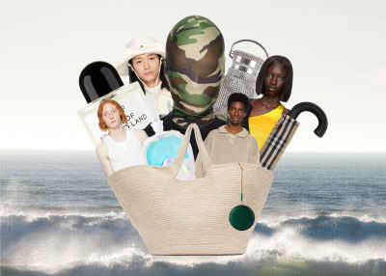

There are few better occasions to watch people than when you’re lying on the beach. Sure, to anybody else, you look like a regular beach-goer, shades on and a book covering the bottom half of your face, but under those tinted lenses and behind those unread pages, a deep study of human nature is underway.

Are they friends or partners? Where did they get that food and how have they managed to keep their beers so cold? But most importantly, what’s in their beach bag?

This summer, we’re lifting the curtain and getting a peek at what some of our favorite creatives are lugging to the sandy shores.

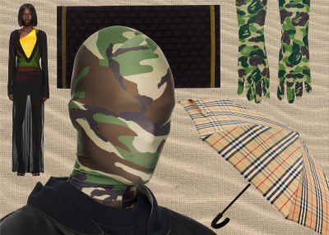

[Vetements Green Camo Styling Mask Balaclava](https://www.ssense.com/en/men/product/vetements/green-camo-styling-mask-balaclava/12622101)

I’m having a no-sun summer. My skin is sensitive and I want to look like a plump teen forever, so I’m wearing this mask eight hours out of the day. I swear, if one ray even touches my forehead....

[Burberry Beige Vintage Check Folding Umbrella](https://www.ssense.com/en/men/product/burberry/beige-vintage-check-folding-umbrella/11782621)

Oh, so you thought I was being cute and kidding about not having any UVs even look at my supple body? Yeah, right! I’m toting along a Burberry umbrella with me for extra coverage. Also, I love the naughty proper check. Reminds me of Posh Spice in, like, 2002.

[Bape Green ABC Camo Gloves](https://www.ssense.com/en/women/product/bape/green-abc-camo-gloves/12849981)

A publicist in LA told me that she drives around with gloves on for sun protection. Publicists in LA are always right. So, I’m bringing these to the beach, too.

[Louisa Ballou Black Caftan Cover Up Dress](https://www.ssense.com/en/women/product/louisa-ballou/black-caftan-cover-up-dress/11146791)

You better bet I’m shrouding myself in this thing.

[Balmain Black All Over BB Beach Towel](https://www.ssense.com/en/women/product/balmain/black-allover-bb-beach-towel/8775671)

Can you imagine? If I was that masked and gloved girl with an umbrella at the beach laying on a monogrammed Balmain towel? Delusional, but glam!

Liana Satenstein is a fashion writer who does deep dives on Madonna’s arm workout, men’s pointy toe shoes, and the allure of shopping bags. She’s also the host of NEVERWORNS, a fab show about people’s stuff they don’t wear—and why.

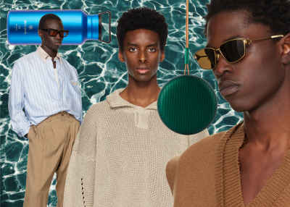

[4SDESIGNS Blue Classic SP Shirt](https://www.ssense.com/en/men/product/4sdesigns/blue-classic-sp-shirt/12478801)

Swaddling your salty, sun-baked skin in some crisp Oxford stripes at the end of a beach day and letting that mf flap in the briny breeze is easily a top five summer feeling. Angelo Urrutia’s big brain once again delivers a super elevated version of a necessary and versatile jawn.

[Bang & Olufsen Green Waterproof Beosound A1 2nd Gen Speaker](https://www.ssense.com/en/everything-else/product/bang-and-olufsen/green-waterproof-beosound-a1-2nd-gen-speaker/8299691)

If I don’t get to play my personal song of the summer (Dori Ghezzi’s “Margherita Non Lo Sa”) on this beautiful portable speaker, I’m throwing a tantrum like a toddler who got sand in their ice cream. But truly, this is the only BO you should be pulling up with this season.

[ROA Beige Cutout Sweater](https://www.ssense.com/en/men/product/roa/beige-cutout-sweater/12336441)

Who knew the boot masters at Roa would make a meshy knit top that’s perfect for not talking to your crush at a bonfire or backyard function? Toss this over a tee or go nips on knits to activate full slut boy summer mode. And don’t worry king, you’ll get their number in the fall.

[Bottega Veneta Gold Square Sunglasses](https://www.ssense.com/en/men/product/bottega-veneta/gold-square-sunglasses/11958041)

There’s no shortage of amazing sunnies out there, but I keep coming back to these Bottega goldies that are both classic 1950s American military and weirdo fashion boy. An investment for sure, and if you’re worried that you’ll lose these like every gas station pair you’ve ever copped, the solution is simple: don’t!

[Snow Peak Blue Titanium Aurora Bottle, 800 mL](https://www.ssense.com/en/everything-else/product/snow-peak/blue-titanium-aurora-bottle-800-ml/9711871)

Don’t be the guy pulling up to the beach with a lukewarm sixer of some saccharine seltzer. Batch up a dicktail beforehand, toss some ice or frozen fruit in, and vacuum seal that shit up so it stays frosty all day. Now you’re the hero and everyone’s love for you will still be strong even after the boys of summer have gone word to Don Henley.

James Harris is the co-host of Throwing Fits, which many people are calling the only podcast that matters. His new favorite thing is unironically giving people the thumbs-up sign.



[C.P. Company Khaki Chrome-R Neck Flap Hat](https://www.ssense.com/en/men/product/cp-company/khaki-chrome-r-neck-flap-cap/12632701)

Gotta have a hat for the beach. Gotta protect your neck and C.P. has great colors and lightweight fabrics.

[Martine Rose Multicolor Dog Tote](https://www.ssense.com/en/men/product/martine-rose/multicolor-dog-tote/12527371)

Everybody needs a good bag for the beach that can fit your towels and other things in. Martine Rose always has great prints, so you can’t go wrong with this dog print tote.

[Gentle Fullness Beige Cocoon T-Shirt](https://www.ssense.com/en/men/product/gentle-fullness/beige-cocoon-t-shirt/13327121)

I like to tie my T-shirts around my head to protect me from the sun, and this graphic tee is great for that.

[Comme Des Garçons Homme Plus Purple animal Shorts](https://www.ssense.com/en/men/product/comme-des-garcons-homme-plus/purple-animal-shorts/5481221)

You need a bright pair of shorts to chill in after coming out of the sea.

[C.P. Company Blue Garment Dyed Swim Shorts](https://www.ssense.com/en/men/product/cp-company/blue-garment-dyed-swim-shorts/12549121)

Once again, C.P. has great colors and light fabrics for swimming trunks. A must.

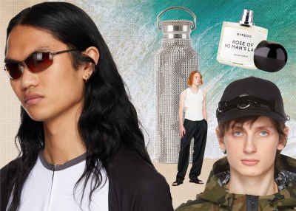

[Inneraum Black Object I44 Ring Cap](https://www.ssense.com/en/men/product/innerraum/black-object-i44-ring-cap/9537841)

At the top of summer, I’m always on the hunt for a good hat that I can wear religiously. This  
will be a guaranteed part of my beach look.

[Maiden Name White Susannah Tank Top](https://www.ssense.com/en/men/product/maiden-name/white-susannah-tank-top/11205491)

Having a tight and sleek tank is a go-to for summer. Doesn’t only make you feel good, but you also get to show the hard work you’ve been putting in at the gym!

[BYREDO Rose Of No Man’s Land Eau de Parfum, 100 mL](https://www.ssense.com/en/everything-else/product/byredo/rose-of-no-mans-land-eau-de-parfum-100-ml/6724771)

The third most important thing in my daily routine is having a clean, crisp scent. I always need to  
know I’m smelling right, especially in the summer. It’s a big contributor to having a good day.

[Oakley Brown Whisker Sunglasses](https://www.ssense.com/en/men/product/oakley/brown-whisker-sunglasses/14162981)

I hate straining my eyes from the sun. A good solid pair of sunglasses also gives a little boost to your look.

[COLLINA STRADA Black & Silver Squiggle Rhinestone Water Bottle](https://www.ssense.com/en/everything-else/product/collina-strada/black-and-silver-squiggle-rhinestone-water-bottle/11188691)

Hydration is key…especially with a bust-down water bottle.

Aijani Payne is a New York-based photographer who shoots fashion and contemporary images. His work often consists of distinct composition and coloring, which sparks vulnerable discussions about human emotions and the experiences of life.



[Helinox Black Nylon Personal Shade Canopy](https://www.ssense.com/en/everything-else/product/helinox/black-nylon-personal-shade-canopy/7297681)

Once you’ve found your spot on a busy beach, you need to assert dominance and protect your prime real estate. We’ve found no better way to do so than setting up this beach throne from Helinox.

[Chimi White Active Snorkel](https://www.ssense.com/en/everything-else/product/chimi/white-active-snorkel/9128431)

Believe it or not, there’s more to a beach visit than people-watching. This Chimi snorkel looks like something Bond would wear to infiltrate an underwater lair, so it’s definitely good enough to look at some cute fishies in the shallows.

[Marni Blue & Black No Vacancy Inn Edition Beach Towel](https://www.ssense.com/en/men/product/marni/blue-and-black-no-vacancy-inn-edition-beach-towel/13249961)

For SS23, Marni teamed up with No Vacancy Inn and brought us all the ultimate beach collab, ranging from blow-up beach balls to bold graphic towels.

[Jil Sander White Press-Stud Bucket Hat](https://www.ssense.com/en/men/product/jil-sander/white-press-stud-bucket-hat/12223981)

360-degree sun protection is essential. Nobody wants their beach trip to be cut short because of an uncomfortably sunburnt neck, which is why this Jil Sander bucket hat is a permanent beach-bag fixture.

[Linda Farrow SSENSE Exclusive Black Bernhard Willhelm Edition ‘The Mask’ Sunglasses](https://www.ssense.com/en/men/product/linda-farrow/ssense-exclusive-black-bernhard-willhelm-edition-the-mask-sunglasses/14403391)

Linda Farrow’s ‘The Mask’ sunglasses are giving medieval plague doctor, and that’s the kind of memento mori that every good beach trip really needs.

<https://www.ssense.com/en-us/editorial/culture/ai-art-chatgpt-liararoux-dall-e-2-stable-diffusion-ann>

By Liara Roux

April 3, 2023

# **MOVING FAST AND BREAKING THINGS: THE PROBLEM WITH AI ART**

## Author Liara Roux Weighs in on Everybody’s Favorite New Technology

## 

## Ai generations: Gavin Park

How derivative is too derivative? Imitation, viewed in a certain light, is flattery; in another, it’s theft. Since new tools were made accessible to the public in late 2022, AI art has taken off; my social media feeds are saturated with it. Some artists have made novel pieces with these tools—fashion photographer [Charlie Engman](https://www.instagram.com/p/Cn4c-DuOFN1/?hl=en) harnesses them to create surreal works whose aesthetics neatly fit in his preexisting oeuvre, while [St4ngeThing](https://www.instagram.com/str4ngething/) generated streetwear inspired by Renaissance era fashions. [Vaquera](https://www.instagram.com/p/CnwjZ7mufwI/) published gothic images of an eerie runway proclaiming “FASHION IS DEAD.”

It’s easy to feel the power of AI. It’s used to iterate quickly on ideas, without needing to labor IRL on a photo set or digitally in Blender. Certain artists have criticized the use of AI, especially in commercial contexts; they claim it’s being used by companies to rip off their work without payment. The American legal system has developed complex intellectual property laws to govern this dilemma—with the ingress of AI, how do we make sure artificial intelligence is playing by the rules we all must follow?

To start, artificial intelligence might be a misnomer. There are two popular forms of “artificial intelligence” right now: generative pretrained transformers (GPTs) and diffusion models—both forms of artificial neural networks (ANNs).

GPTs are the most common type of ANNs at the moment. They’re the ones responsible for the most successful text-based “AI” programs. OpenAI’s ChatGPT has been wildly popular, with over 100 million users at the time of writing. I’ve been using it to practice my French and a friend used it to write copy for his startup. Unlike previous language processors, which were trained solely on text considered relevant to their given task, GPTs are trained on large and generalized swaths of text and only later given specific directives.



Diffusion models, like Stable Diffusion and DALL-E 2, are ANNs that focus instead on generating images. They’re trained on endless images which are all associated with certain text descriptions. They’re then given a “noise” image that essentially looks like old-school television static. From there, they’re instructed to find an image in the noise. If you’ve ever looked at clouds and saw a face, or stared at the ceiling too long and started seeing strange images emerge, you’ve essentially done the same.

Given the way they function, I don’t think it’s fair to call either of these models truly intelligent. They are not sufficiently self-aware. Even if you ask Stable Diffusion or ChatGPT to define themselves, they are not truly, deeply self-referential as an integral part of their makeup. If ChatGPT had spent a great deal of time being trained on itself and conversations it had with others, then trained onward and onward on its reflections (or outputs) on that data, then perhaps it might be slowly heading towards consciousness.

Consciousness, our individual and unique perspective, is what allows creative work to be truly transformative, which is critical when we consider copyright law. In fact, these AIs often spit back content that matches text they were trained on word for word. Most high school plagiarists are smart enough to go in and shuffle things around. It’s easy to tell when AI art has been intentionally guided by an artist into creating a specific aesthetic or when someone has just entered in generic prompts. Engman told SZ Magazin that, “when I added an emotional layer like ‘award winner’ or ‘proud,’ the AI interpreted the image in a new [way].” The AI generator can depict these abstract concepts, but can’t empathize insofar as to experience them. So while many people claim that these AI models are artists, or even curators, I think it’s more appropriate to compare them to any other piece of equipment an artist might use. A paintbrush, a camera.



In the ‘80s, Andy Warhol famously appropriated for his work copyrighted photographs, movie stills, logos, advertisements, and soup cans. Whenever he was sued, he would defend his work as transformative. Not unlike a Catholic mass, wherein a humble wafer is transubstantiated into the literal body of Christ, Warhol claimed he turned these objects into ART.

At the time, this caused a stir, and even now, decades later, his work is controversial; in 2022, the Supreme Court heard arguments from a photographer, Lynn Goldsmith, who claimed she was entitled to compensation for Warhol’s use of her work. The court has not yet published its final decision on the matter.

When it comes to commercial work, imitations are a bit harder to justify. "I think moviemakers might be surprised by the notion that what they do can't be fundamentally transformative," Supreme Court Associate Justice Elena Kagan mused during the Warhol arguments. Indeed, a filmmaker cannot just read a book and decide they want to make a movie about it. To ensure that writers are properly compensated for their labor, filmmakers are required to pay for the rights to their stories.

Stable Diffusion and ChatGPT, on the other hand, have not, to my knowledge, compensated anyone for the contributions their intellectual property has made to these models. Artists and writers have had their entire oeuvres swallowed up into behemoth repositories that these models are trained on. They even at times spit out work that is eerily similar to the work of artists that they may have arguably stolen from.

I am a part of the AI training sets. My selfies and my writing have been consumed. [There’s a bot that’ll imitate my tweets.](https://huggingface.co/huggingtweets/liararoux?text=My+dream+is) A 4chan post in January even accused me of being AI-generated myself. In my younger years I hung around anarchist hacker types who would argue that information wants to be free. They’d say that imitation is only natural; memetic communication is crucial to the evolution of humanity. In my early years on the internet that certainly felt true, watching trends and information spread fungus-like throughout our digital networks. Now I watch corporations skim the cream off my cool kid friends, making big bucks off their free labor on social media.

Caroline Caldwell, a friend who’s an illustrator and a tattoo artist, told me her designs are already frequently lifted by graphic designers creating labels for edgy beer brands or inspirational shirts. She was worried AI will only make this problem worse. She’s barely scraping by, pained and frustrated. For her, art is about making something human, something connective. Of course AI art could be used to make appealing imagery, she said, but could it make something that genuinely made someone feel understood, seen, less alone? We can look at these images as just a collection of pixels, judge them on purely aesthetic appeal, but for so many people, the human element behind the art is actually the most important. It’s not just about looking at an image; it’s about connecting with someone, maybe even feeling the same thing they do.



While ChatGPT is essentially given large collections of texts and left to run wild, only refined later in the processes, models like Stable Diffusion need to be trained on cleaned and calibrated data. Massive amounts of it. This data preparation is usually contracted out to companies who are largely based in the Global South, paying exploitative rates to their employees. Everyone who’s used CAPTCHA has participated in training AI; typing in words, letters, identifying photos of sidewalks and streetlights. For a while, a group of 4chan-based trolls would enter a slur into every CAPTCHA they came across, hoping to maliciously insert the word into ebooks that were digitized using CAPTCHA. OpenAI and other companies have built-in guidelines for AI, but the idea of working with cheap or free labor terrifies me. Who’s to say there isn’t a group of 4chan trolls out there, clicking on children in the hopes that it’ll make Teslas more likely to run them over, purposefully tagging offensive or traumatizing imagery as safe? Why are these companies focusing so hard on generating text and images? These are such inherently human tasks—human neural architecture is already oriented around processing language and imagery. Wouldn’t it be more interesting to look at AI’s potential applications in medical research, safety measures, or risk analysis areas where it can compensate for humans’ homegrown fallacies and shortcomings? AI has been used to improve driving safety, to prevent people from crossing into another lane, to help doctors identify early stage cancer, to improve the efficiency of the power grid and public transportation. Artist and educator Melanie Hoff pointed out that we can reclaim AI for ourselves, that AI’s “structure is a more exciting tool than using preexisting structures and taking what those structures produce.” She explained that “the downside [of ChatGPT and Stable Diffusion] is that people are using large premade datasets...instead of making their own databases and their own AI structures.”Hoff pointed me to a work she made, [Partisan Thesaurus](http://partisanthesaurus.com/), a rudimentary AI that linked commonly associated words; she trained it on two different bodies of text: one set of speeches and writing by Republican, another by Democrats. It lays bare biases which might have otherwise been obscured. She also pointed me to [Bomani Oseni McClendon](https://bomani.rip/black-health-book)’s work, particularly a piece called Black Health, a book which scraped WebMD to look for references to “Black” or “African.” The results were a disturbing condemnation of the biased nature of the medical field.These works are much more interesting to me than simply exploiting existing content for the sake of making even more content that exists solely to be consumed or to advertise. These pieces use AI to simplify work that might have been challenging and time-consuming for a human, but that is straightforward for a computer, and clarifies things that might have otherwise been obscured. Shouldn’t that be the point of AI?



Journalist [Edward Ongweso Jr](https://www.vice.com/en/article/bvmk9m/everybody-please-calm-down-about-chatgpt) told me that he’s concerned these tech companies are trying to build a god: “They're [thinking] if we integrate [AI] into our society, it will uplift us...act as an overseer to organize our resources better and ensure better politics.” Instead of building humanistic systems, designed to improve people’s lives, these AI “gods” will be used to extract further profits, to extract time and attention from humans.AI is a murky area; it doesn’t help that these companies are so secretive. Their algorithms and datasets are all proprietary, carefully guarded. All of my friends who work in the field apologetically told me they couldn’t speak on the record, because their employers forbid it. Given the effect Silicon Valley’s “move fast and break things” ethos has had on our politics, our social lives, our brains, perhaps it’s finally time to slow these companies down, insist that whatever systems they’re creating are ones that are built with humanity in mind, not just further extracting as much wealth as possible from a world that’s stretched so thin.The work of George Washington Carver comes to mind here. You can’t just build a farm, grow the same crops on the same land year after year. You’ll exhaust the soil. You need to rotate through different crops, give something back. Is ChatGPT or Stable Diffusion truly giving anything back?When OpenAI was initially founded, it was intended to be a nonprofit to promote transparency around artificial technology. Instead, it created a for-profit subsidiary that is now even more secretive than Google’s AI research division. While I want to hope that Silicon Valley has learned to temper its speed from the last time it moved fast and broke things, it’s up to the users to advocate for the appropriate use and regulation of this new technology. While in the hands of a capable artist, AI can be used to create something meaningful—even valuable—for society, how many more photos, videos, and texts do we need competing for our attention? What’s the point of avoiding paying an illustrator’s fee to work with an AI that’ll make an image that is by its very nature derivative?